### Day 6- 108415746-Srilekha Bhimavarapu

### Regular expressions symbols list

^ the start of the string

$ the end of the string

. wilscard which matches any character, except newline

| matches a specific character or group of characters on either side

\ used to escape a special character

() checks for a string, create and stores the variables

{} repeats preceding character

! logical NOT

[] checks for any single character in the character set specified in []

? matches 0 or 1 of the previous

+ matches 1 or more of the previous

### Feature of Linux

* Free and open source – Linux is completely free of cost and open source means that modification of code, analysis of code or selling copies of the enhanced code can be done by anyone.
* Extremely flexible – It is incorporated itself into embadded products like watches, digital equipment and supercomputing severs.
* Lightweight Infrastructure – It consumes lesser storage space and it’s installation requires 4GB to 8GB of disk space.
* Multiuser and Multitasking – It supports multiple users simultaneously accessing the system and running multiple programs at the same time.
* Portability and Customization – Linux can run on various hardware platforms and user can customize the operating system to their preference.
* Command-Line Interface (CLI) – It offers a powerful CLI for interacting with system and performing complex tasks.
* Graphical User Interface (GUI) – While Linux is known for CLI, it also provides a GUI for a more user-friendly interface.

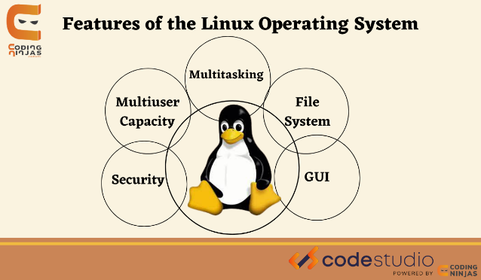

### Kernel

* It is the core of an OS acting as the central hub that manages communication between software and hardware.
* It manages system resources, handles communication between hardware and applications, and ensures the smooth operation of the entire system.

### BASH: Bourne Again Shell

* It is a command line interpreter and scripting language primarily used in Linux and other Unix-like OS. Bash is an enhanced version of the original Bourne shell.

### Difference b/w Linux and windows

* Linux is known for its flexibility, customization, and strong security while windows is user-friendly, widely supported, and offers a broad range of compatible applications, according to multiple sources.
* Linux is open-source OS, where as windows is not an open-source.

### Basic components of Linux

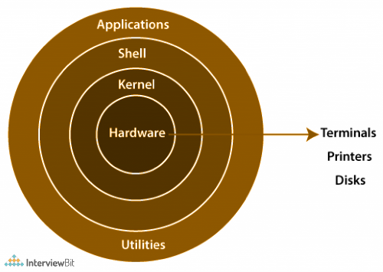

* Hardware Layer: This is the physical layer of the system including the CPU, RAM, Storage devices, and input/output devices. Kernel interacts directly with this layer to manage resources.
* Kernel: It is the heart of the OS, acting as a bridge between hardware and software. It is the foundation upon which the entire OS is built.
* Shell: It is the user interface that allows users to interact with kernel. It interprets commands and translate them into instructions for the kernel.
* System Libraries: These are the collection of functions and routines that provide essential services to applications.
* System Utilities: These are the programs that perform specific tasks, such as managing files, users, and processes.

### Is it legal to edit Kernel? when do you think we have to in case?

* Yes, it is legal to modify. It can be useful in scenarios like performance optimization, hardware compatibility, or when developing custom software or embedded devices.

### What is LILO? Explain

* LILO is the short-form for Linux Loader is a boot loader program used in Linux OS. It is responsible for loading the kernel and other essential parts of the operating system into memory when a computer starts or restarts.

### What is shell? How many shells are there and what are they?

* In Linux, a shell is a command-line interpreter, a program that allows users to interact with the operating system by typing commands.
* Bourne Again Shell (Bash): The most widely used shell in Linux systems, known for its features and versatility.
* Z Shell (Zsh): A highly customizable shell with features like auto-completion and extensive scripting capabilities.
* Fish Shell (Fish): Designed for ease of use, with features like syntax highlighting and automatic suggestion.
* Bourne Shell (sh): A legacy shell that served as the foundation for other shells.
* C Shell (csh): A shell with syntax similar to the C programming language.
* Korn Shell (ksh): A shell that combines features from other shells and is used in various systems.

### What is swap space?

* Swap space is often a dedicated disk partition that is used to extend the amount of available memory.

### What is Mount? how do you mount and unmount file system in Linux?

* Mount refers to attaching a file system (like a USB drive, a hard disk, or a network share) to the exiting directory structure, making its contents accessible.
* To mount a file: sudo mount [options] <device> <mount_point>
* To unmount a file: sudo umount <mount_point>

<device>: The device name  
<mount_point>: The directory where you want to mount the device

### What is chmod command? how to use it?

* chmod command modifies the read, write, and execute permissions of specified files and the search permissions of specified directories.
* chmod <options> <permissions> <file_or_directory_name>

chmod: short for change mode

<options>: Optional flags, such as -R for recursive modification.

<permissions>: Specifies the desired permissions using either symbolic or octal notatioin.

<file_or_directory_name>: The file or directory to modify.

### Can you add a new user account? Crate a new user in different ways

### 

### Can you change the password of a user? How do you do that?

* Yes, in many operating systems and platforms, it's possible to change a user's password
* 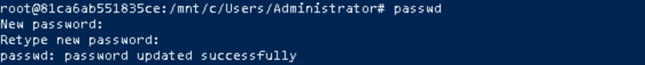

### What is diff between Process and Thread?

* A process is a program in execution, while a thread is a unit of execution within a process.
* Processes are independent, with their own memory space, while threads within the same process share memory and resources.
* Threads are lighter than processes, meaning they require fewer resources and have faster context switching.

### Grep Command

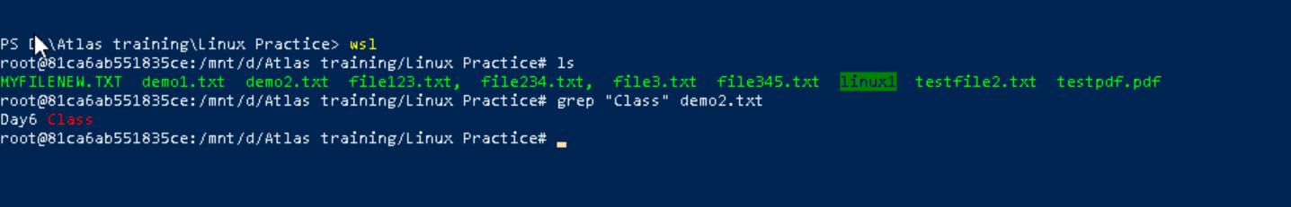

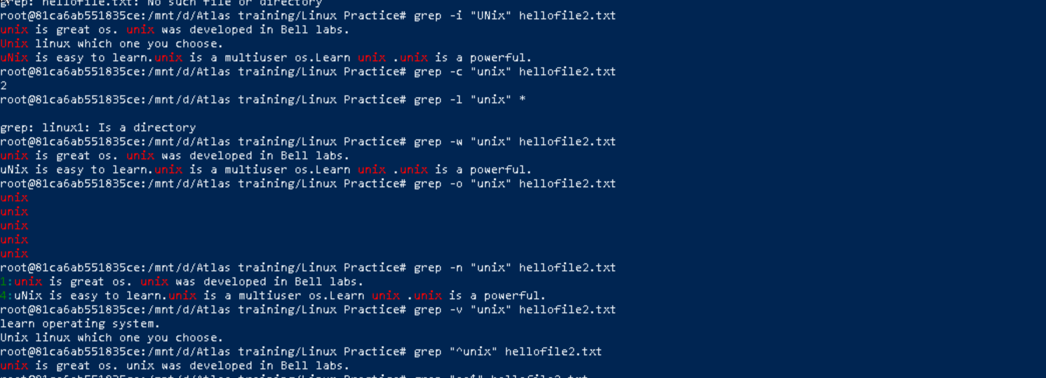

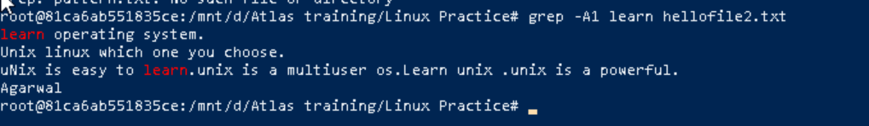

### AWK COMMANDS

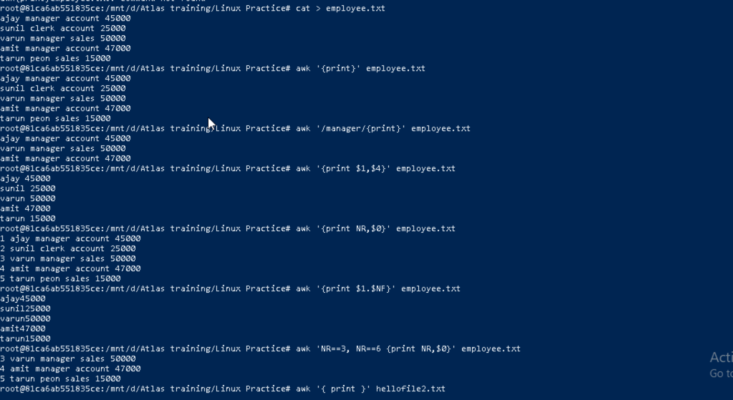

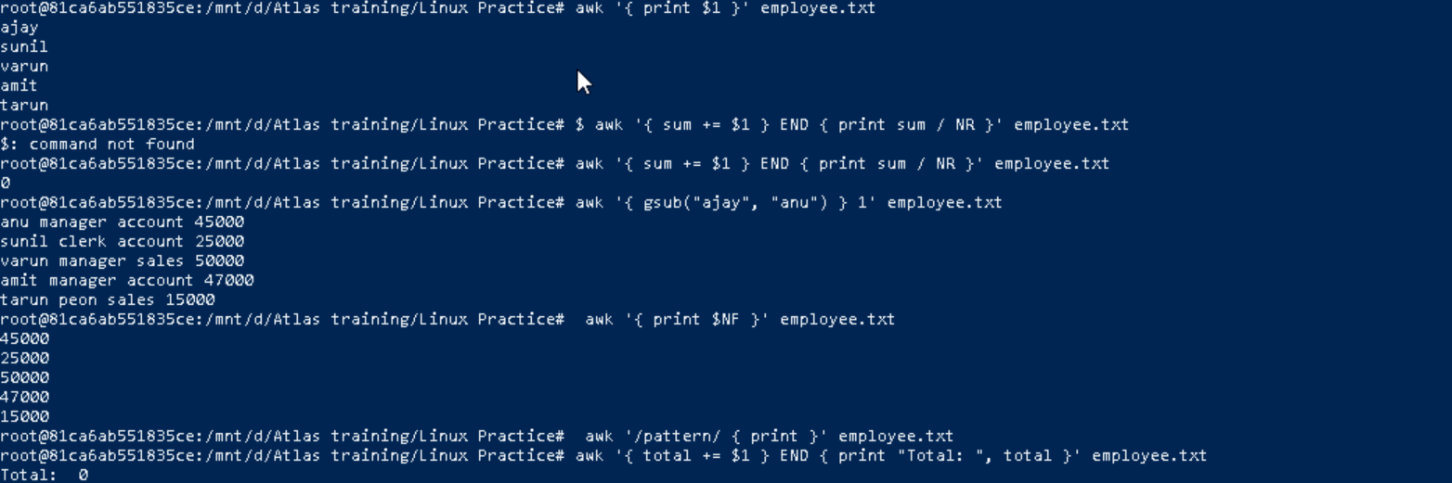

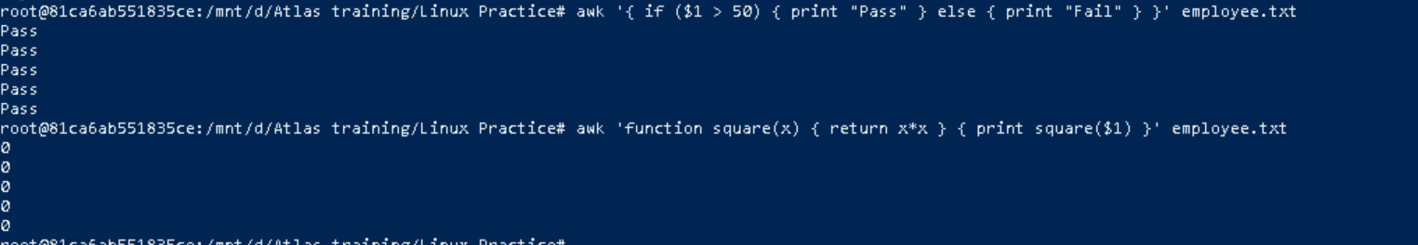

### How to check file access permission in Linux?

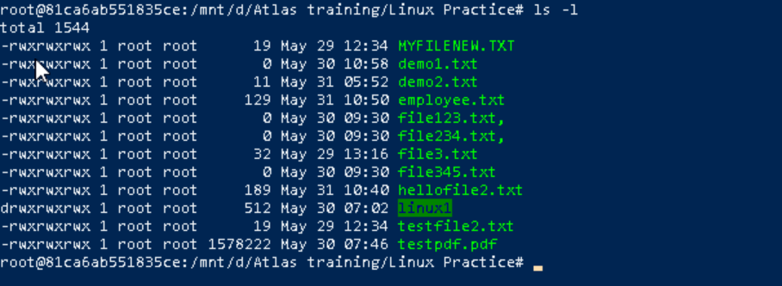

### What are the default permissions for a new file?

* The operations that a user can carry out on files can either be read, written, execute or a combination of these operations.
* On Linux, by default, when we create new files, they are given rw—r--r-- permissions.
* The r, w, and x signify the read, write, and execute permissions, respectively.
* rw- (owner): The file owner can read and write the file.
* r-- (group): Members of the file's group can read the file.
* r-- (others): Other users (not the owner or group member) can read the file.

### What is the command to change the permission to read only for the owner, group and all other users?

### 

### Can you change the file permissions to match the following:

* owner: Read and Write
* group: Read
* other: no permissions (None)

### 

### What was the command for changing the file permissions to -rw-r-----?

### 

### Change chmod.exercises permissions to -rwxr-x—x

### 

### What was the command for changing the file permissions to -rwxr-x--x

### 

chown -c master file1.txt: used to change the owner of the specific file

### Can you define what is a process?

A process is a running instance of a program. Linux treats everything as a process from your shell terminal to system services. Each process has a process id (PID) a unique number assigned by the OS.

### What is command to check foreground process and background process

Command is ps

### Can you list all the running processes?

### 

### What will ps -f command do?

### 

### Can you create a variable name with your name in it ?

### 

### Can you make the above name variable read only

### 

### Now will unset or delete the variables

It won’t work as we used read only in current session. To unset or delete we need to close the current session and need to open a new one.

### Can u try to add a list of your friends names in an array and try to printout?

### 

### Can you print all the list at once in an array

### 

### 

### Symbolic Link

